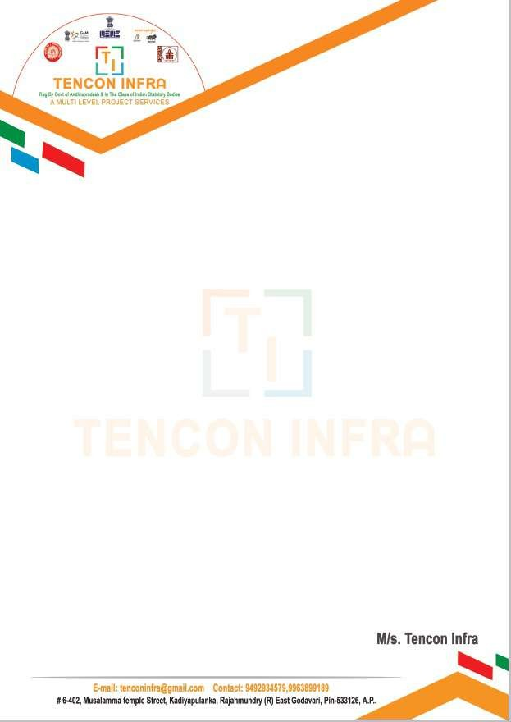GGGI

INTERNSHIP CERTIFICATE

This is to certify that \*NULUKURTHI NAVYA LAKSHMI

Reg.No \*230387401099

Of ADITYA DEGREE COLLEGE FOR WOMEN’S, KAKINADA underwent internship in

MS-AZURE in TENCON INFRA

from 15-04-2025 to 15-06-2025

The overall performance of the intern during her internship is found to be Satisfactory.